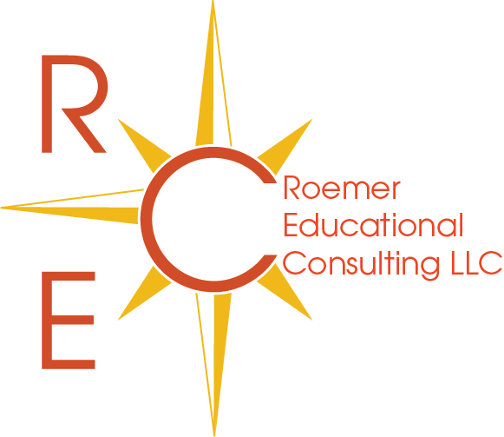

R.E.C. College Application Resumé Package

The college application resumé is your opportunity to move beyond the numbers game of college applications and present yourself in the best possible light. It can also be one of the most difficult parts of the application process to complete properly. College application resumés are:

- Submitted directly to colleges for application consideration;
- Used to complete the activities sections of college applications;
- Presented at admissions interviews;
- Presented for scholarship consideration;
- Shared with counselors, teachers and other recommenders for stronger college recommendations;
- Suitable for employment applications.

Do you really know what’s important to include in your resume? Do you know how to present the information in the best possible light?

Is your resumé college application ready?

Roemer Educational Consulting offers superior college application resumé services designed specifically to provide your student with the greatest possible admissions advantage. Utilizing our exclusive college application resumé process, Sally Roemer gathers all required information, spends time with your applicant reviewing their activities, passions and interests, and ultimately returns to you a beautifully formatted resumé specifically suited to all aspects of the college process. When it’s time for you to complete your applications, you can relax with the knowledge that one of the most important and difficult tasks is already completed in an appropriate, professional and detailed manner!

College Application Resume Package: $399

