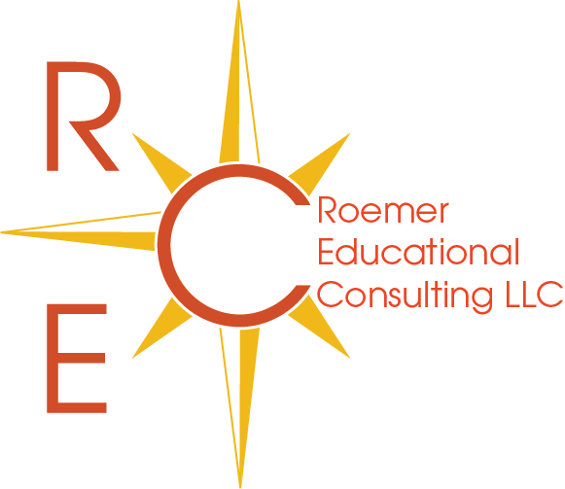

R.E.C. College Application Essay Editing Services

Roemer Educational Consulting, LLC offers professional essay editing services for students who may not require assistance with the entire college search and application process but still seek support through the college application essay process.

Personal Statement Package (up to 650 words): $725

- Includes an extensive topic brainstorming session (as needed), thorough essay guidance, and up to three full essay critiques for the main college application essay known as the personal statement (Common App, Coalition Application, or individual college application personal statement up to 650 words).

Supplemental Essays (essay word limit): 60 cents per word

- In addition to the personal statement, many colleges include their own school-specific essays known as writing supplements or supplemental essays. This category also includes essays required for scholarship applications, honors college applications, direct admission program applications or any essay other than the personal statement noted above.

